

NOTICE OF MEETING OF THE BOARD OF DIRECTORS OF
ASSOCIATED STUDENTS OF CSU CHANNEL ISLANDS, INC.

NOTICE IS HEREBY GIVEN, to the general public and to all of the Board of Directors of Associated Students of CSU Channel Islands, Inc., a California nonprofit public benefit corporation, that:

A meeting of the Board of Directors will be held on Thursday, April 12, 2012 at 7:40 a.m., pursuant to Education Code Section 89921 et seq., at California State University Channel Islands, Student Union Coville Conference Room, located at One University Drive, Camarillo, CA 93012, to consider and act upon the following matters:

- Call to Order: 7:42 AM

- Members Present: Missy Jarnagin, Veronica Palafox, Damien Peña (teleconference), Dr. Terry Ballman, Ryan Hunnewell , Richard Wagner, Dulce Lopez, Elysse Farnell, Chris Carroll, Tanya Yancheson, Spencer Keaster, Ben Pereira, Edwin Lebioda
  - Members of the Public Present: Lundon Templeton, Chantyl Vasquez, Dr. Genevieve Evans Taylor , Christine Thompson,

- Approval of Minutes: Minutes to be approved during the Board’s May meeting.

- Public Forum: No members of the public addressed the Board.

- Outstanding Business
  - Reserve Policy – update (Dr. Evans Taylor): Board is asked to review and vote on during the May Board meeting.
  - ASI Student Body Center Fee (Dr. Evans Taylor): Would like the Board to know the fee will not be going forward by the Student Fee Committee to the President due to the committee being dissolved of this duty.
  - 2012 ASI & SG Election Update (Ms. Farnell): The finals results are up on the ASI Website (SEE APPENDIX A). This year, 15% of our student body voted.
  - New Dolphin Mascot Costume and Name (Ms. Farnell): Currently 253 voted for the mascot name; Ekho is favored. Is collaborating with the art department to develop the mascot costume. The art department will be sending their student submissions to the ASI office.

- New Business
  - FY 2012/13 Budget Allocations (Ms. Palafox): See appendix B; conducted multiple meetings with the committee, initially made all cuts that did not align with the BASC procedure guidelines. After the cuts we had a difference of $17,000. The committee wanted to submit a balanced budget, so cuts were made to the Student Life programs because Student Organizations had such a small percentage cut of the budget and ASI entities and ASI Administration does not have any other sources of funding.
    - The major cut to University Outreach was due to LEAP’s GPA requirement for students. Dean Peña said this was no longer a restriction for students to be in LEAP.
    - The projected budget is based on a 4,000 annualized student head count.
    - Notification will be given to all requesters by the Chair of the BASC.
    - Dr. Evans Taylor specified that this is one of the most important decisions made at the ASI Board level. The committee did an exceptional job of balancing the budget. The ASI Board needs to decide if this is the allocation that they want to approve. The other option is to tap into reserves that we are looking into spending down.
      - Dean Peña, will yield to the committee and the Board, Student Life is a resilient program and will make the best of whatever allocation provided.
      - Mr. Keaster stated that once changes are made to the LEAP program than they can request additional funds from the ASI Board.
      - Mr. Lebioda suggested that we look at the budgets that are left from this year and reallocate the remaining balance to the Student Life programs.
      - Mr. Wagner moves to approve, Ms. Lopez seconds, motion passes with one abstention by Dean Peña.
  - Bylaws change pertaining to ASI entity status (Dr. Evans Taylor): One of the challenges that Ms. Thompson and Dr. Evans Taylor has faced is the minimal amount of staffing available. Have seen that the ASI entities do not have enough staffing that can provide them with their needs. Currently entities have volunteers that advise the groups who have separate duties and responsibilities on campus. Being an advisor is not part of their job description and they unfortunately can’t provide the entities with the time and attention necessary. These ASI entities are major organizations who don’t have enough staffing that can provide them with support. There is also potential risk management issues with SPB not having a full time professional overseeing their events. Currently there is an executive order 1068 that does not allow Auxiliaries to advise student organizations so we initially thought that in order to provide these entities with professional staffing, we would need to take from ASI reserves and give to Student Life programs who can advise student organizations. After some thought we realized this is not the route we wanted to go. Had a conversation with Ray Murillo, Associate Director of Student Programs for the CSU, who advised that we make the ASI Entities a function of the ASI Board. Would like to ask the Board if they foresee an issue with making the ASI Entities a function of the ASI Board.
    - Dr. Evans Taylor met with all of the student entities who have agreed to this change.
    - Ms. Lopez indicated that they need an advisor who can provide a state and political perspective.
    - Will vote on changes of the Bylaws for next meeting in May.
  - New ASI Hires (Dr. Evans Taylor): New hires for ASI benefits the entire student body because it provides for the entities to serve better the students and the CI Community. The activity of ASI and the Student Union has increased significantly throughout the year. The student body has increased significantly throughout the year, which is exciting and challenging. Ms. Thompson and Dr. Evans Taylor have to be visionaries and detail oriented at the same time which is extremely difficult. Dr. Evans Taylor would like to hire an Entity Advisor and Office Administrator Assistant. ASI currently has a student Office Assistant who has taken much of the work load off of the professional staff. Dr. Evans Taylor would like to hear feedback from the ASI Board regarding the proposal of increasing two new positions and looking at Ms. Thompson’s position.
- Mr. Hunnewell asked where these positions would work. Dr. Evans Taylor indicated that details have not been finalized.
- Mr. Keaster asked if Ms. Thompson’s current position would need to be filled. Dr. Evans Taylor indicated that Ms. Thompson’s position would simply increase.
- Dr. Evans Taylor would like to hire immediately.
- Dean Peña supports the new approvals and feels it meets the University Mission Statement. Hiring takes about three months; would like to hire before the next fiscal year.
- Mr. Lebioda made a recommendation within the next three weeks we get position descriptions and other financial numbers.
- Mr. Carroll encourages the Board to look at all of the documents and have a firm idea of how we would like to move forward.
  - Entity leader 1 year appointment (Ms. Farnell): Mr. Carroll feels that the current candidate has such knowledge that she can transition easier. The current candidate has a trainee which will shadow this person for a semester and come to all ASI Board meetings. The Assistant Editor will be in the position all year so the Nautical would maintain some consistency. Bringing this to the Board because the position will also be a Board of Director.
    - Ms. Palafox, motions to approve the position for one semester. Mr. Carroll seconded. Motion approved.
  - June Board meeting:
    - Can we change to June 14, 2012? (Dr. Evans Taylor): Motion to cancel the June 7th ASI Board Meeting in order to choose a later date within the month. Mr. Hunnewell seconds. Motion approved.
      - Board Retreat/Training to follow meeting.
  - McKee Transparency Act and cost per copy for open record requests (Dr. Evans Taylor): As an auxiliary we are now mandated to give information as requested and charge a small fee for each page.
  - ASI Assessment Process (Dr. Evans Taylor): Assessment is a high priority to determine if we are meeting the needs of the students. It’s also a way for us to write down what we do so we can maintain a learning organization. If there are things missing or you would like us to track please let Dr. Evans Taylor know.
  - Student Union and Student Assistant Surveys (Dr. Evans Taylor): Will be promoting this assessment survey via web, FaceBook, marketing, and word of mouth. Please take the survey. The Student Union Student Assistants are also taking a survey to determine if they are learning what we hoped would learned.

- Adjournment 8:58 AM

Next ASI Board Meeting is scheduled for Thursday, May 3, 2012 at 7:40 a.m. in the Student Union Coville Conference Room.

Agenda respectfully submitted by Christine Thompson.
Appendix A:
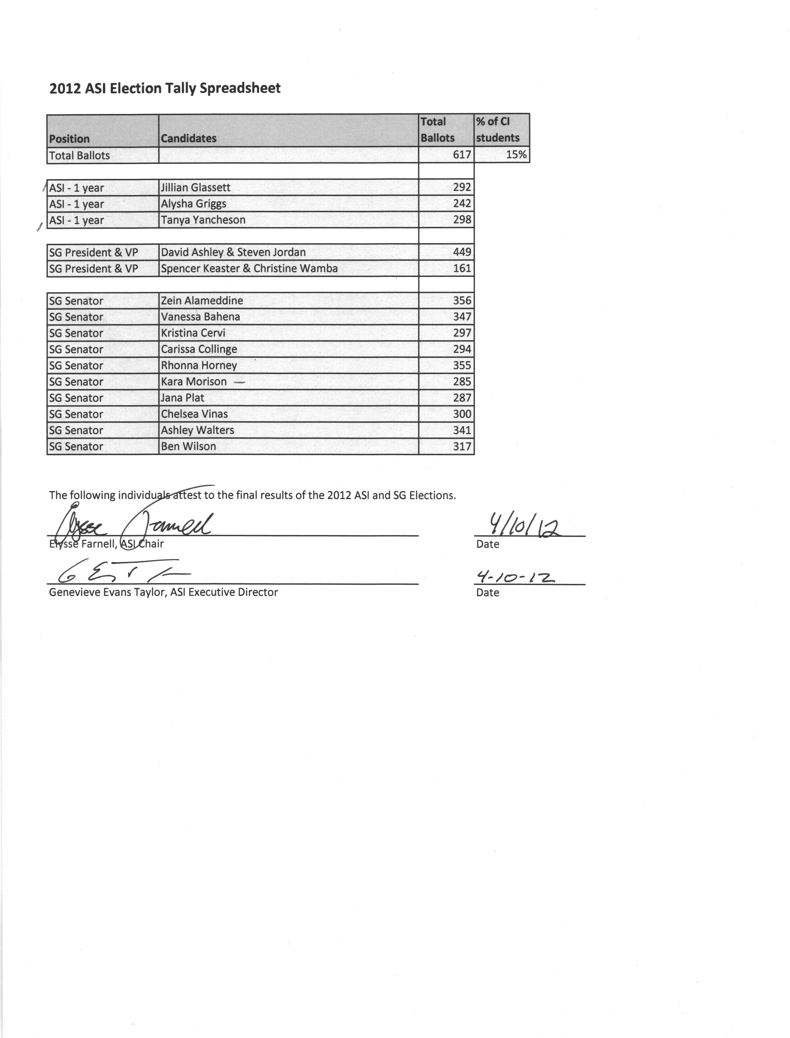
sf

Appendix B:



