

NOTICE OF MEETING OF THE BOARD OF DIRECTORS OF
ASSOCIATED STUDENTS OF CSU CHANNEL ISLANDS, INC.

NOTICE IS HEREBY GIVEN, to the general public and to all of the Board of Directors of Associated Students of CSU Channel Islands, Inc., a California nonprofit public benefit corporation, that:

A meeting of the Board of Directors will be held on Thursday, May 3, 2012 at 7:40 a.m., pursuant to Education Code Section 89921 et seq., at California State University Channel Islands, Student Union Coville Conference Room, located at One University Drive, Camarillo, CA 93012, to consider and act upon the following matters:

- Call to Order: 7:41 AM
  - Directors Present: Edwin Lebioda, Ryan Hunnewell, Elysse Farnell, Richard Wagner, Veronica Palafox, Chris Carroll, Spenser Keaster, Tanya Yancheson, Missy Jarnagin, Dean Damien Peña, Jason Barnes
  - Members of the Public Present: Christine Thompson, Dr. Genevieve Evans Taylor, Chelsea Vinas, Lundon Templeton, Chantyl Vasquez, Grier King, David Ashley
- Approval of Minutes:
  - April 5 & April 12: Ms. Jarnagin Approved the minutes, Mr. Wagner seconds, motion passes.

- Public Forum: No members of the public addressed the Board of Directors.

- Financial Report: Trending analysis for all of the entities shows expenditures and revenue through March 2012. The graph below is a representation of entities and miscellaneous items budgeted compared to actuals. Everyone is spending correctly. All invoices must be in before June 30th. Next week the state will release the May revised budget, the $2 million trigger cut may be more; revenues are down in California more than what the legislature projected so there is a larger deficit.

- Entity and Community Relations Reporting
  - Student Government: Mr. Barnes: Transitioning new people into Student Government; will host last meeting tonight, May 3rd where we will be approving Bylaw revisions and the University Hour Resolution. At CHESS, Student Government won the Spirit Award for the second year in a row.
  - Student Programming Board: Ms. Palafox: Held Battle of the Majors, which was 5 events for 5 days. Hosted Dolphin Palooza with around 500 attendees, consisting of a range of age amongst the attendees. Allowed clubs and orgs to table which brought different students to the event. Brought a food truck to campus during Dolphin Palooza which created a positive reaction from the attendees. SPB is transitioning new officers for next year.
  - Nautical Yearbook: Ms. Farnell: Transitioning new members; Allie Woerner will be training in order for her to obtain the Editor in Chief position next year. Working on the Senior Spotlights, starting proofs and reviews of the book.
  - CI View: Ms. Vasquez: Finished the May issue (the final issue) and will start working on the Orientation issue.
  - Community Relations: Mr. Wagner: Commented on the Maximus awards; in the future tell Community Members if they were nominated or finalists. The BT&P dinner was well attended, large turnout. Dolphin Days turn out of employers was the largest group that we’ve had so far. Found all Career Development programs to be outstanding this year. Welcome bags are in process of completion. Plan to attend the Ribbon Cutting of the Grand Entrance. Have plans for an all county mixer, date to be determined.

- Outstanding Business
  - ASI Stole (Ms. Farnell): All applicants going through eligibility checks. The stole has been ordered and will be available for pick up next week. Elysse will send out an email to all recipients.
  - Reserve Policy – ACTION ITEM (Dr. Evans Taylor): Calls for questions and a vote. Mr. Wagner moves to approve the reserve policy, Mr. Lebioda seconds, and motion passes.
  - New Dolphin Mascot Costume and Name (Ms. Farnell): The new dolphin name is Ekho. Currently, there is only a few submissions of the dolphin mascot.
  - ASI Professional Staff- ACTION ITEM (Dr. Evans Taylor): presented a proposal to increase the professional staff last Board meeting; requesting two new positions and changing Ms. Thompson’s position. Looking to open for discussion.
    - ASI Assistant Director Position, what are the major changes along with Ms. Thompson’s current position.
      - The major difference is documenting what Ms. Thompson currently does, the new title and Position Description better represents what she is currently acting as.
      - Other changes include the degree in which Ms. Thompson oversees the facility which requires more high level thinking as well as the ability to be a visionary for ASI/ Student Union rather than processing paperwork. This position will have oversight of a new professional staff person, the ASI Support Coordinator.
    - Dean Peña: the students have been asking for an entity advisor for a long time; he is thankful to Dr. Evans Taylor for taking a proactive approach.
    - Ms. Palafox motions to approve the three position descriptions with Dr. Evans Taylor’s ability to make amendments to them, Mr. Keaster seconds. Motion passes.
    - Board Discusses Funding of positions:
- Dr. Evans Taylor presents a graph indicating how the money will be spent out of ASI’s excess reserves. The numbers used for enrollment is conservative; CI may be enrolling more students.
- With reserves lowering, how does this affect the plans to spending down the revenue by buying items necessary for the Student Union Building? Those will come from the Student Union reserves.
      - Mr. Wagner: convinced that we need two additional staff, what do we need to do to go forward? Dr. Evans Taylor stated that this is the decision of the Board.
      - Ms. Yancheson motions to approve the funding of the positions through ASI reserves, Ms. Palafox seconds, and motion passes (Dr. Ballman voted in favor of the motion via email).

- New Business
  - Interview ASI Director 2 year position: Candidate Ms. Chelsea Vinas: currently a freshman and double majoring in psychology and communication; has a desire to help people. Started as an intern in Student Government and has been appointed to the Senate position. Is eager to get involved.
    - Ms. Palafox: what does the CI way mean?
      - Holding integrity, holding to your values no matter what you are doing. We are a community and together we will make CI grow.
    - Mr. Keaster: What is the purpose of the Board?
      - Allocate a budget to entities and clubs and organizations.
    - Mr. Hunnewell: what would you say your role would be on this Board?
      - Speaking up and being an asset to the role while utilizing my boisterous personality. Also hope to bring other experiences to the Board.
    - Mr. Carroll why do you want to serve on the Board and what is the most important part of the position?
      - Important, although may not happen this year leaves a legacy for other students. Hardest part would be early morning meetings.
    - Mr. Barnes What does it feel like to have integrity?
      - Helping others and working for others to do the right thing.
    - Mr. Keaster, if you would’ve known that it was allowed, would you have ran for the Board position as well as the Student Government Senate position?
      - Yes
    - Discussion of the candidate:
      - Mr. Carroll: she is motivated and would be outstanding in the position.
      - Mr. Barnes: she has grown a lot and has a unique dedication and motivation.
      - Mr. Palafox: commends her being a freshman who is so involved.
      - Ms. Jarnagin: candidate statement was really good.
      - Mr. Hunnewell: in general, would reopen the position back up when we only have one applicant for a position but in this case, this is the only candidate we need to look at because she is so great.
      - Mr. Carroll motions to offer Ms. Vinas the position as a Board of Director to the ASI Board, Ms. Yancheson seconds, and motion passes.
  - Faculty Term on ASI Board (Dr. Ballman): Dr. Evans Taylor: The challenge of having a faculty member on the Board is that we always want to have the Faculty voice because we believe in shared decision making. However, we have faculty on 10 month positions which makes it difficult because they are often traveling, doing research etc. The ASI Bylaws say that if a Director misses 3 meetings they are off the Board. Would like the Board to look at the possibility of faculty representatives being excused from the Board during the summer term.
- Mr. Keaster: if they don’t attend the summer training, would they be trained through other means?
  - Dr. Evans Taylor: yes, all members who miss training will be trained.
- Dr. Evans Taylor suggested the Board’s decision be placed in the Bylaws because it is a stumbling block for recruiting faculty Board members and would like authors’ intent when/if we all leave.
- The faculty representative will be sent all correspondence during the summer term.
- How is it different that students who do not live here have to come in for Board meetings?
  - Students apply with the knowledge it is a one year position. Most faculties now are 9 month contracts or academic year contracts.
- What is the process when looking for a faculty member?
  - Looking for a faculty who is tenure track and has a history with the University and who is here for student development and learning.
- Dr. Evans Taylor will look at summer schedules and meetings to determine when/if all summer meetings are necessary.
  - Outgoing Directors: Dr. Evans Taylor: this is our last meetings and therefore, thank you for the time you’ve spent on the Board this year. The Board has accomplished a lot during the year.
      - Dr. Evans Taylor recognized Mr. Wagner for playing a significant role on the Board for many years.

- Adjournment 9:15 a.m.

Next ASI Board Meeting is scheduled for Thursday, July 5 2012 at 8:00 a.m. in the Student Union Coville Conference Room.

Agenda respectfully submitted by Christine Thompson.
Appendix A:
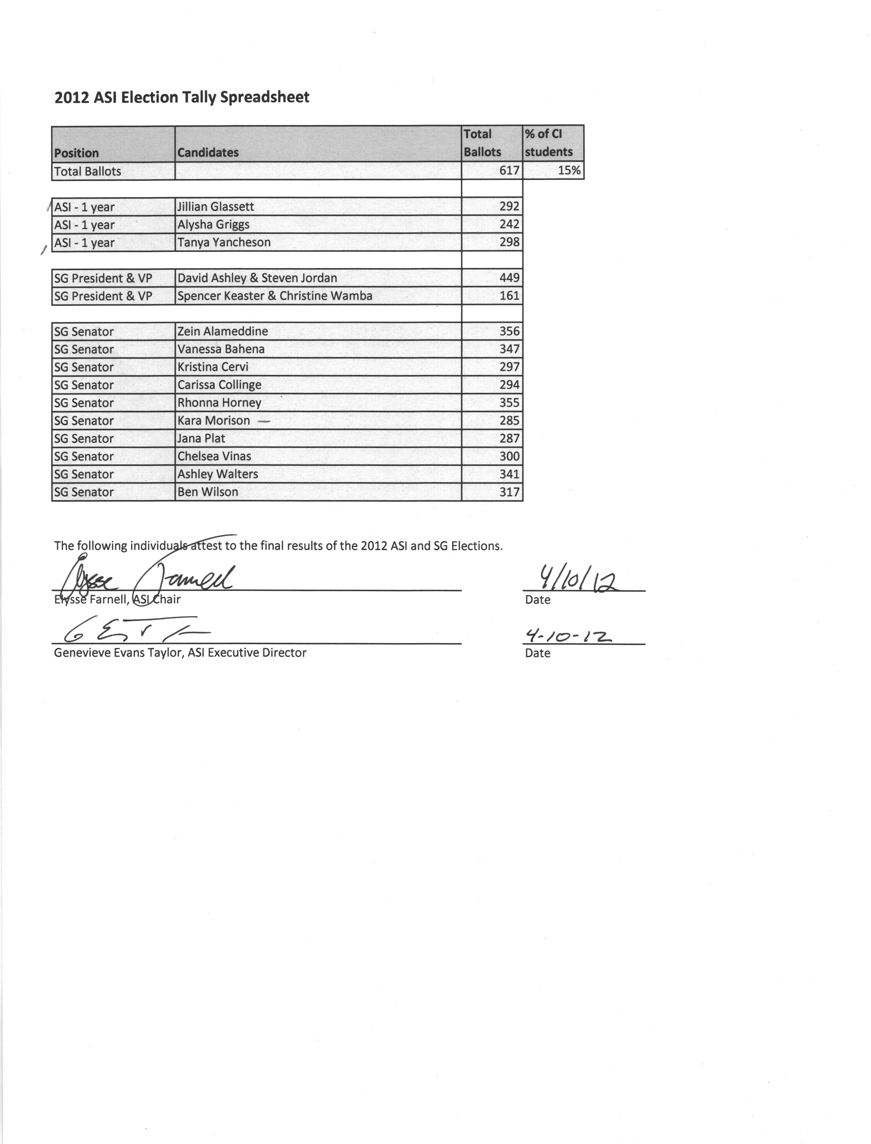
sf

Appendix B:




