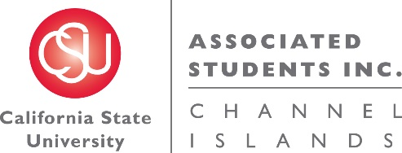

NOTICE OF MEETING OF THE BUDGET ALLOCATION AND SPENDING COMMITTEE OF
ASSOCIATED STUDENTS OF CSU CHANNEL ISLANDS, INC.

NOTICE IS HEREBY GIVEN, to the general public and to all of the Board of Directors of Associated Students of CSU Channel Islands, Inc., a California nonprofit public benefit corporation, that:

A meeting of the Budget Allocation and Spending Committee (BASC) will be held on Thursday, October 20, 2016 at 7:40 a.m., pursuant to Education Code Section 89921 et seq., at California State University Channel Islands, Student Union Coville Conference Room, located at One University Drive, Camarillo, CA 93012, to consider and act upon the following matters:

- Call to Order:

- Approval of Agenda:

- Approval of Minutes:

- Public Forum:

- Old Business:

- New Business:
  - INFORMATIONAL ITEM: Analysis of 16-17 unfunded student organization requests.
  - ACTION ITEM: Hillel Student Organization Budget Allocation Appeal (G. DeLong)
  - INFORMATIONAL ITEM: Financial Training (C. Derrico)

- Future BASC Agenda Items:
  - BASC Procedures Updates
  - ASI Entity Budget Requests Presentations
  - ASI Administration Budget Request Presentation
  - Student Union Budget Request Presentation
  - Campus Areas Budget Request Presentation
  - Overage of ASI reserves
  - Non-renewed student organization allocation

- Questions:

- Adjournment:

Next BASC Meeting is scheduled for Thursday, October 27, 2016 at 7:40 a.m. in the Student Union Coville Conference Room.

Agenda respectfully submitted by Jennifer Shoemaker, ASI Budget Assistant.

