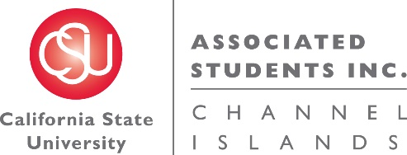

NOTICE OF MEETING OF THE BUDGET ALLOCATION AND SPENDING COMMITTEE OF
ASSOCIATED STUDENTS OF CSU CHANNEL ISLANDS, INC.

NOTICE IS HEREBY GIVEN, to the general public and to all of the Board of Directors of Associated Students of CSU Channel Islands, Inc., a California nonprofit public benefit corporation, that:

A meeting of the Budget Allocation and Spending Committee (BASC) will be held on Thursday, October 27, 2016 at 7:40 a.m., pursuant to Education Code Section 89921 et seq., at California State University Channel Islands, Student Union Coville Conference Room, located at One University Drive, Camarillo, CA 93012, to consider and act upon the following matters:

- Call to Order:

- Approval of Agenda:

- Approval of Minutes:

  - Minutes from October 20, 2016

- Public Forum:

- Old Business:

- New Business:
  - INFORMATIONAL ITEM: Campus-wide instructions for 17-18 budget (M. Jarnagin)
  - ACTION ITEM: BASC Procedures Updates (G. DeLong)

- Future BASC Agenda Items:
  - BASC Procedures Updates
  - ASI Entity Budget Requests Presentations
  - ASI Administration Budget Request Presentation
  - Student Union Budget Request Presentation
  - Campus Areas Budget Request Presentation
  - Overage of ASI reserves
  - Non-renewed student organization allocation
  - Permanent BASC meeting time

- Questions:

- Adjournment:

Next BASC Meeting is scheduled for Wednesday, November 9 at 7:40 a.m. in the Student Union Coville Conference Room.

Agenda respectfully submitted by Genesis DeLong, ASI Interim Director.

