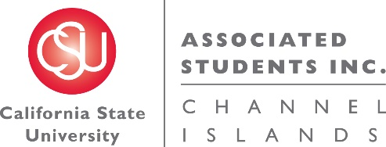

NOTICE OF MEETING OF THE BUDGET ALLOCATION AND SPENDING COMMITTEE OF
ASSOCIATED STUDENTS OF CSU CHANNEL ISLANDS, INC.

NOTICE IS HEREBY GIVEN, to the general public and to all of the Board of Directors of Associated Students of CSU Channel Islands, Inc., a California nonprofit public benefit corporation, that:

A meeting of the Budget Allocation and Spending Committee (BASC) will be held on Thursday, December 1, 2016 at 11:05 a.m., pursuant to Education Code Section 89921 et seq., at California State University Channel Islands, Student Union Coville Conference Room, located at One University Drive, Camarillo, CA 93012, to consider and act upon the following matters:

- Call to Order:

- Approval of Agenda:

- Approval of Minutes:
  - ACTION ITEM: Minutes from November 29, 2016

- Public Forum:

- Old Business:

- New Business:
  - ACTION ITEM: BASC Budget Recommendation

- Future BASC Agenda Items:
  - BASC Procedures Updates
  - Overage of ASI reserves
  - Non-renewed student organization allocation
  - Permanent BASC meeting time

- Questions:

- Adjournment:

Next BASC meeting is scheduled for January 2017.

Agenda respectfully submitted by Genesis DeLong, ASI Interim Director.

