STUDENT UNION GRADUATE ASSISTANT
Compensated Educational Leadership Opportunity
Associated Students Inc., Student Union
California State University Channel Islands

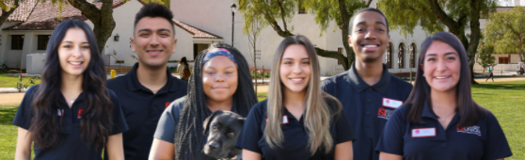
apply! | ci_studentunion | 805-437-8932 | ASI@csuci.edu
About The Role

The Student Union Graduate Assistant is a compensated educational leadership opportunity.
This position works alongside the ASI Leadership Team to provide effective development, planning and implementation of Student Union (SU) services, programs, projects and facility operations. This role helps oversee the student union building and special projects within the building.

- Employment Rate: $18.25 hourly, 20 hours per week

- Building Operation Hours: Monday- Thursday, 7:40am-8pm, Friday, 7:40am-5pm, Closed Weekends.

- Start Date: Fall Semester 2023- The week of August 14, 2023. Required on campus employee training dates to be scheduled the week of August 14, 2023.
Responsibilities

- Assists with Student Union team development, hiring, and daily staff support.

- Assists with daily facility operations, building maintenance, and special projects.

- Participates in the development, facilitation, implementation, and assessment of student training programs, policies, procedures, and programs developed by the department.
Requirements

- Must pass a background test.

- Must be enrolled in a graduate program at CSU Channel Islands in Educational Leadership, Higher Education Concentration, Education, Counseling, Business or related field, with a minimum of four (4) units.

- Must maintain a grade point average of 3.0 (B) or better with no course grades lower than a C+; must be able to commit to twenty (20) hours of work per week for two consecutive semesters (fall and spring).

