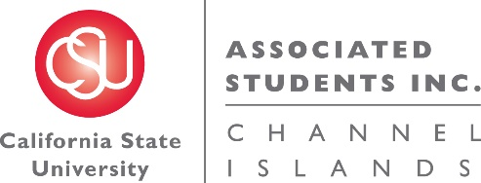

NOTICE OF MEETING OF THE BUDGET ALLOCATION AND SPENDING COMMITTEE OF
ASSOCIATED STUDENTS OF CSU CHANNEL ISLANDS, INC.

NOTICE IS HEREBY GIVEN, to the general public and to all of the Board of Directors of Associated Students of CSU Channel Islands, Inc., a California nonprofit public benefit corporation, that:

A meeting of the Budget Allocation and Spending Committee (BASC) will be held on Thursday, November 17, 2016 at 7:40 a.m., pursuant to Education Code Section 89921 et seq., at California State University Channel Islands, Student Union Coville Conference Room, located at One University Drive, Camarillo, CA 93012, to consider and act upon the following matters:

- Call to Order: 7:48 a.m.
  - Members present: Corinne Smith, Elizabeth Heim, Helen Mancias, Dr. Susan Andrzejewski, Jennifer Moss
  - Members of the public: Annie Block-Weiss, Genesis DeLong, Cindy Derrico

- Approval of Agenda:
  - M/S/P (H. Mancias/S. Andrzejewski)
Motion passed 4-0-1

- Approval of Minutes: None

- Public Forum:

- Old Business:

- New Business:
  - INFORMATIONAL ITEM: Budget Request Presentations
    - 7:50 a.m. Intercultural Services (Amana McMurray and Venus Tamayo on behalf of Motoko Kitazumi)
    - 8:10 a.m. New Student Orientation and Transition Programs (Ariana Robles)
    - 8:30 a.m. Student Leadership Programs (Kem French)

- Future BASC Agenda Items:
  - BASC Procedures Updates
  - Overage of ASI reserves
  - Non-renewed student organization allocation
  - Permanent BASC meeting time

- Questions:

- Adjournment: 8:42am

Next BASC Meeting is scheduled for Thursday, November 17 at 11:05 a.m. in the Student Union Coville Conference Room.

Agenda respectfully submitted by Jennifer Shoemaker, ASI Budget Assistant.

