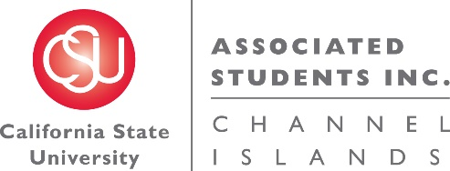

NOTICE OF MEETING OF THE BUDGET ALLOCATION AND SPENDING COMMITTEE OF
ASSOCIATED STUDENTS OF CSU CHANNEL ISLANDS, INC.

NOTICE IS HEREBY GIVEN, to the general public and to all of the Board of Directors of Associated Students of CSU Channel Islands, Inc., a California nonprofit public benefit corporation, that:

A meeting of the Budget Allocation and Spending Committee (BASC) will be held on Thursday, November 17, 2016 at 11:05 a.m., pursuant to Education Code Section 89921 et seq., at California State University Channel Islands, Student Union Coville Conference Room, located at One University Drive, Camarillo, CA 93012, to consider and act upon the following matters:

- Call to Order: 11:11 a.m.
  - Members present: Corinne Smith, Elizabeth Heim, Helen Mancias, Dr. Susan Andrzejewski, Jennifer Moss
  - Members of the public: Annie Block-Weiss, Genesis DeLong, Cindy Derrico

- Approval of Agenda:
  - M/S/P (S. Andrzejewski/J. Moss)
Motion passed 4-0-0 (Elizabeth Heim arrived after the approval of the agenda)

- Approval of Minutes: None

- Public Forum: None

- Old Business: None

- New Business:
  - INFORMATIONAL ITEM: ASI Administration Budget Request Presentation (G. DeLong)

- Future BASC Agenda Items:
  - BASC Procedures Updates
  - Overage of ASI reserves
  - Non-renewed student organization allocation
  - Permanent BASC meeting time

- Questions:

- Adjournment: 11:45 a.m.

Next BASC Meeting is scheduled for Tuesday, November 29 at 7:30 a.m. in the Student Union Coville Conference Room.

Minutes respectfully submitted by Genesis DeLong, ASI Interim Director.

